Questão 01

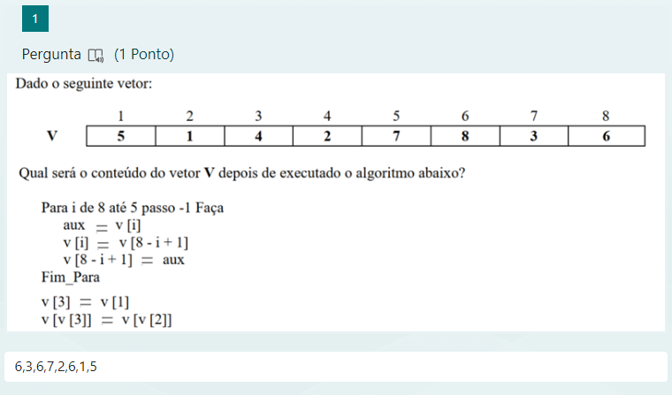

Questão 02

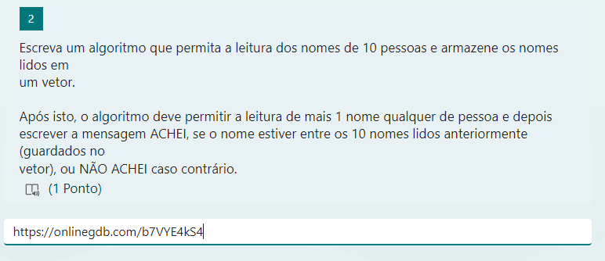

<https://onlinegdb.com/b7VYE4kS4>

Questão 03

<https://onlinegdb.com/2wvOW1pgD>

Questão 04

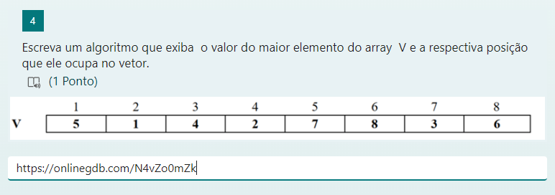

<https://onlinegdb.com/N4vZo0mZk>

Questão 05

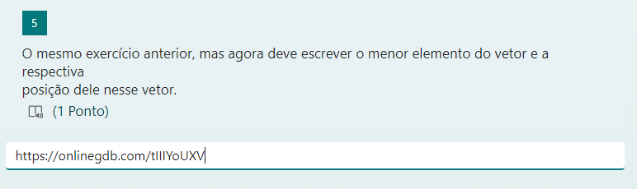

<https://onlinegdb.com/tIIIYoUXV>

Questão 06

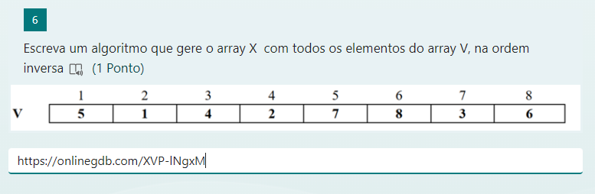

<https://onlinegdb.com/XVP-lNgxM>

Questão 07

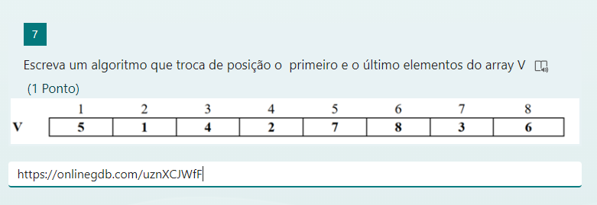

<https://onlinegdb.com/uznXCJWfF>

Questão 08

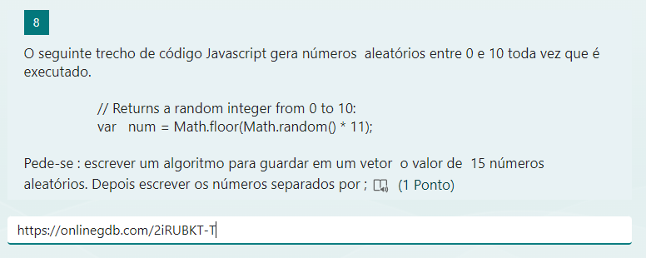

<https://onlinegdb.com/2iRUBKT-T>

Questão 09

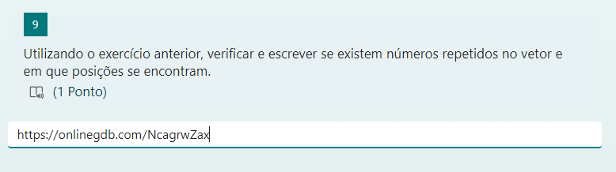

<https://onlinegdb.com/NcagrwZax>